02/08
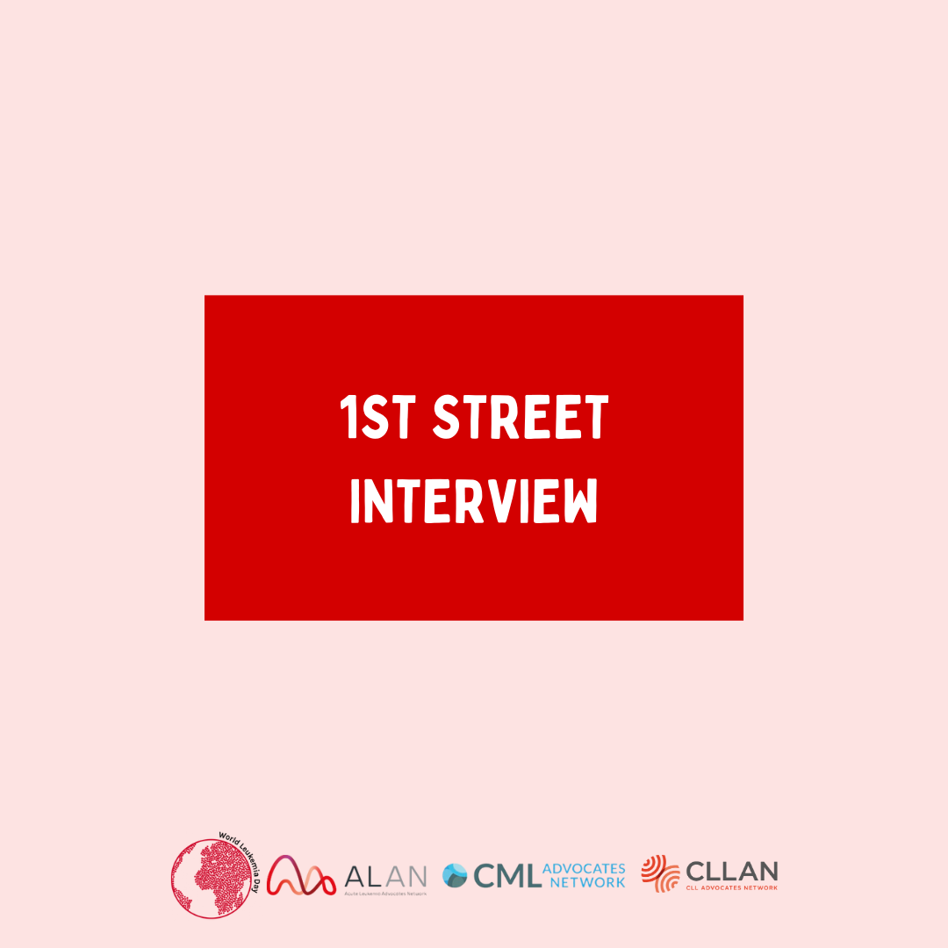

TBD
#BeLeukemiaAware#WLD24#WorldLeukemiaDay #countdown #yourenotalone#WorldLeukemiaDay #Leukemia #PatientAdvocacy#Alan#BeAware #August #streetinterview #symptoms
Facebook: @ALANacuteleuk @cmladvocates @CLLAdvocates
Instagram: @alan_acuteleuk @clladvocates #cmladvocates

4/08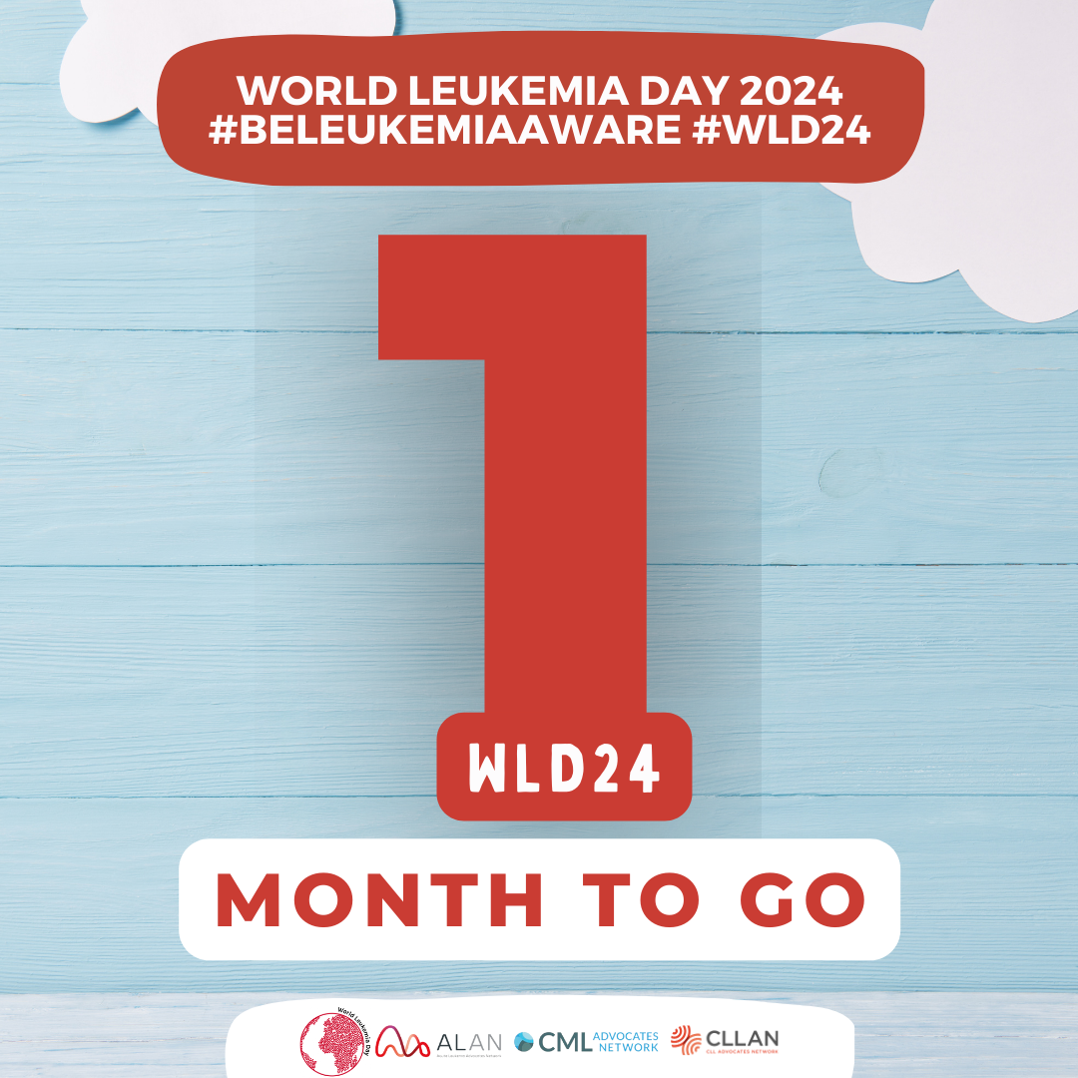
Only 1 month left until World Leukemia Day 2024, don't forget... #BeLeukemiaAware
#BeLeukemiaAware#WLD24#WorldLeukemiaDay #countdown #yourenotalone#WorldLeukemiaDay #Leukemia #PatientAdvocacy#Alan#BeAware #August #1monthleft
Facebook: @ALANacuteleuk @cmladvocates @CLLAdvocates
Instagram: @alan_acuteleuk @clladvocates #cmladvocates

05/08
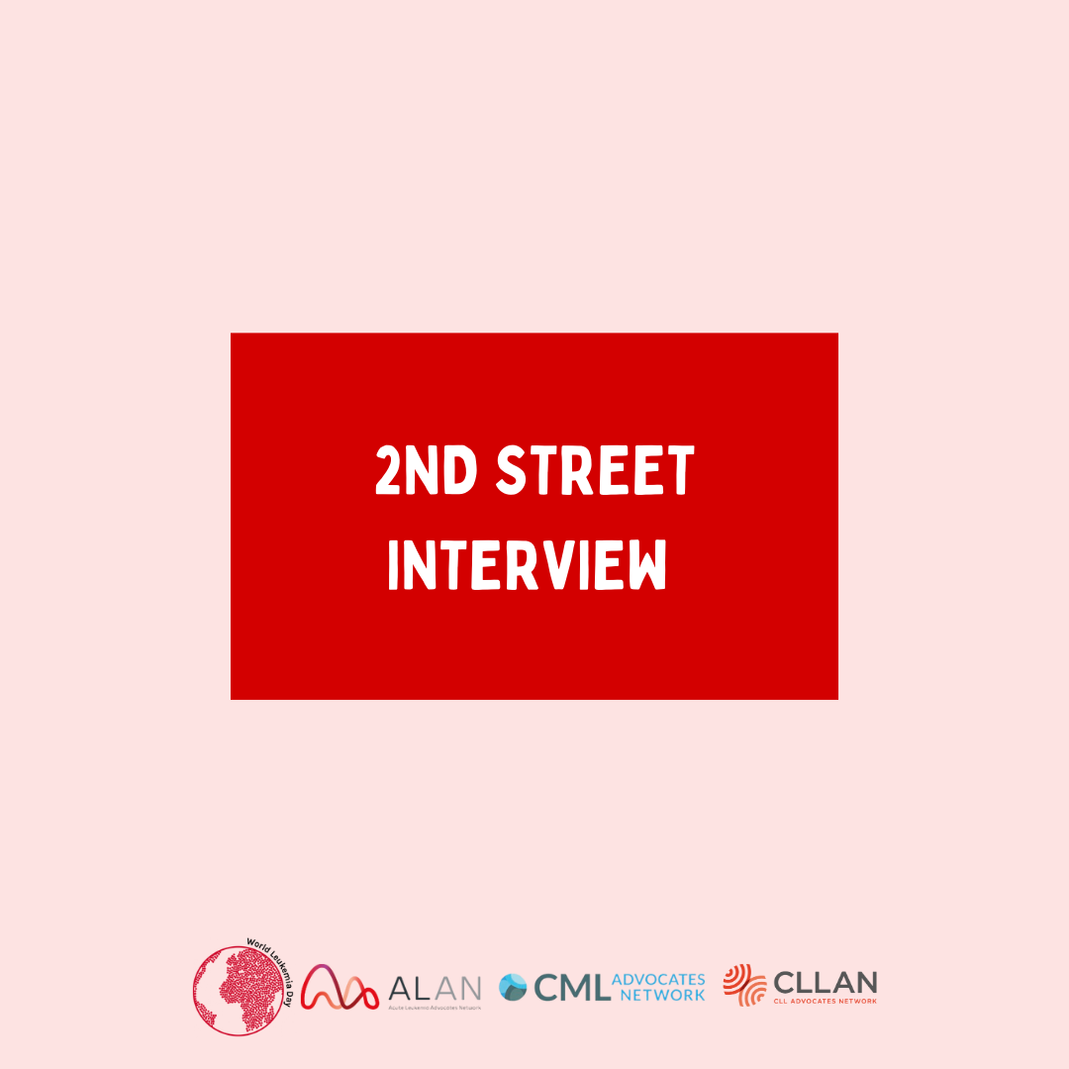
TBD
#BeLeukemiaAware#WLD24#WorldLeukemiaDay #countdown #yourenotalone#WorldLeukemiaDay #Leukemia #PatientAdvocacy#Alan#BeAware #August #streetinterview #symptoms
Facebook: @ALANacuteleuk @cmladvocates @CLLAdvocates
Instagram: @alan_acuteleuk @clladvocates #cmladvocates

07/08
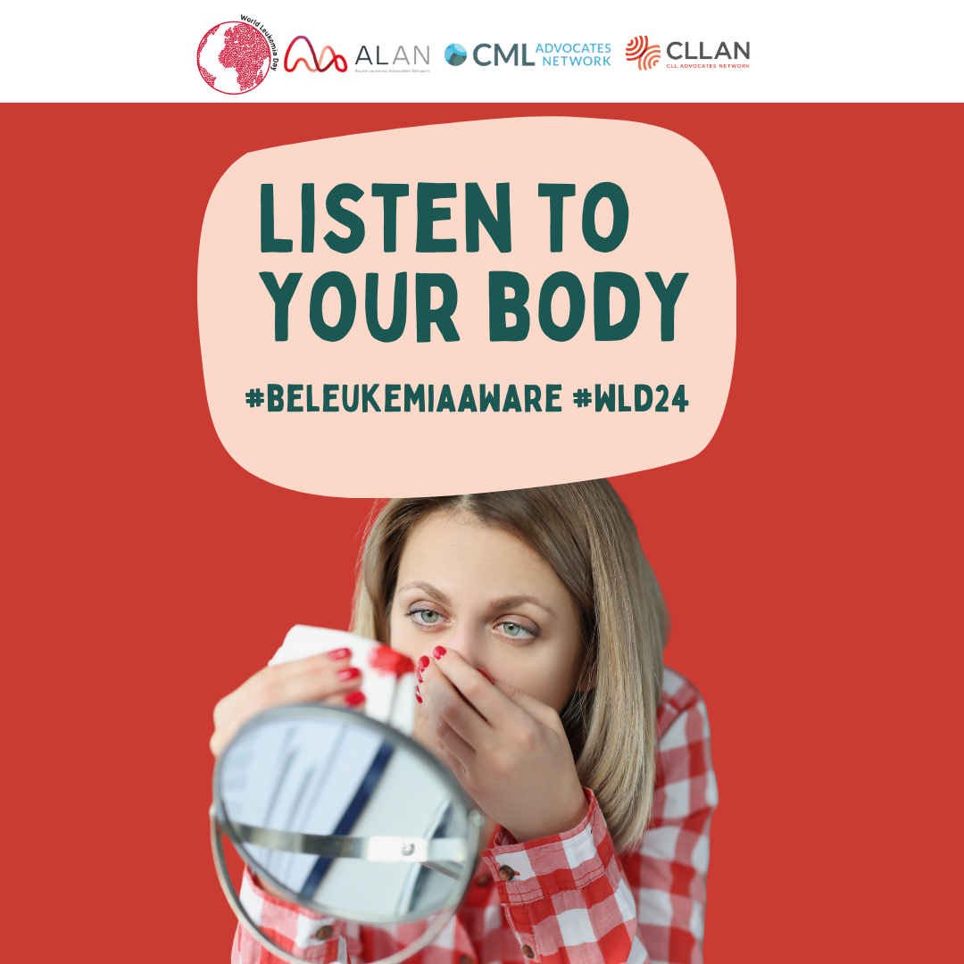
In leukemia, the excessive number of abnormal white blood cells in the bone marrow can interfere with platelet production. As a result, patients with leukemia often have a very low platelet count (thrombocytopenia). This leads to a reduced ability of the blood to clot, which can cause spontaneous or prolonged bleeding even in the absence of trauma or obvious injuries.
#BeLeukemiaAware#WLD24#WorldLeukemiaDay #support #healthcare #symptoms #leukaemia #yourenotalone#WorldLeukemiaDay #Leukemia #PatientAdvocacy#Alan#BeAware #listentoyourbody #hope #symptoms #August #bleeding
Facebook: @ALANacuteleuk @cmladvocates @CLLAdvocates
Instagram: @alan_acuteleuk @clladvocates #cmladvocates
09/08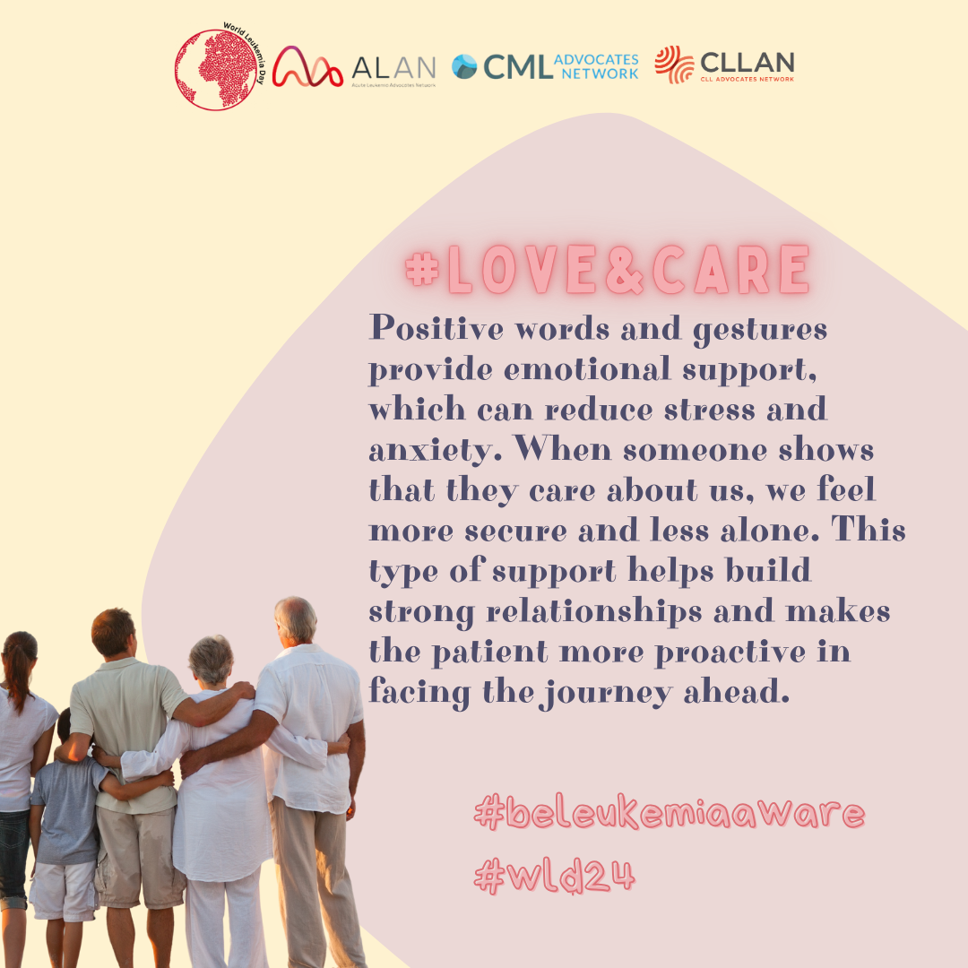
When someone shows us appreciation, it creates a sense of belonging and connection. This is particularly important in social and work contexts, where feeling part of a cohesive group can reduce the sense of isolation and improve the quality of life.
#BeLeukemiaAware#WLD24#WorldLeukemiaDay#caregivers #patients #friends #family #yourenotalone#WorldLeukemiaDay #Leukemia #PatientAdvocacy#Alan#BeAware#LoveandCare #August
Facebook: @ALANacuteleuk @cmladvocates @CLLAdvocates
Instagram: @alan_acuteleuk @clladvocates #cmladvocates
12/08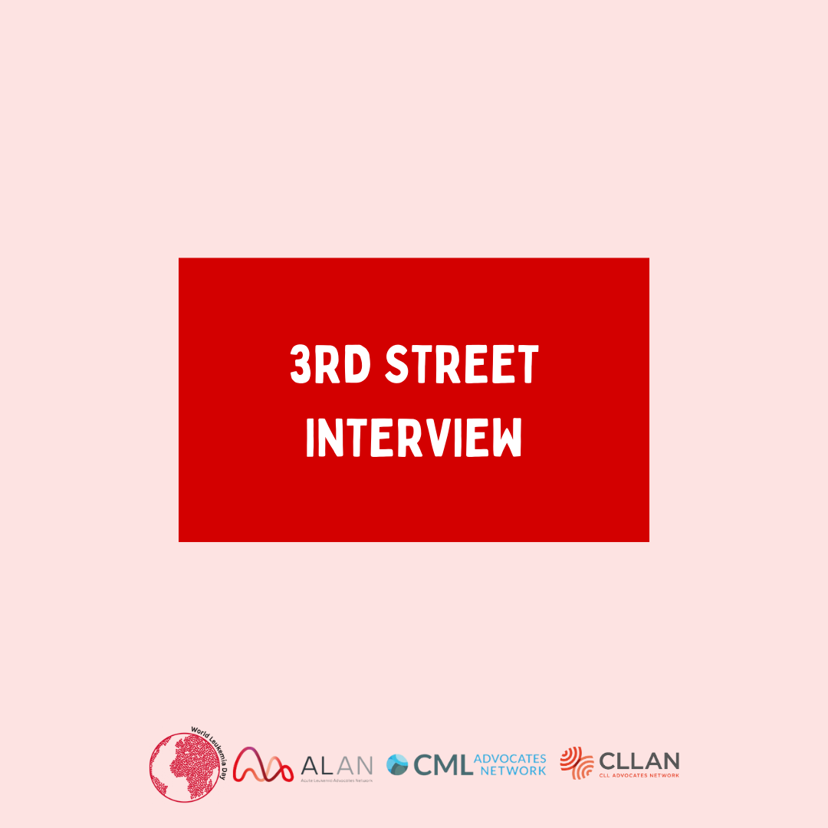
TBD
#BeLeukemiaAware#WLD24#WorldLeukemiaDay #countdown #yourenotalone#WorldLeukemiaDay #Leukemia #PatientAdvocacy#Alan#BeAware #August #streetinterview #symptoms
Facebook: @ALANacuteleuk @cmladvocates @CLLAdvocates
Instagram: @alan_acuteleuk @clladvocates #cmladvocates

13/08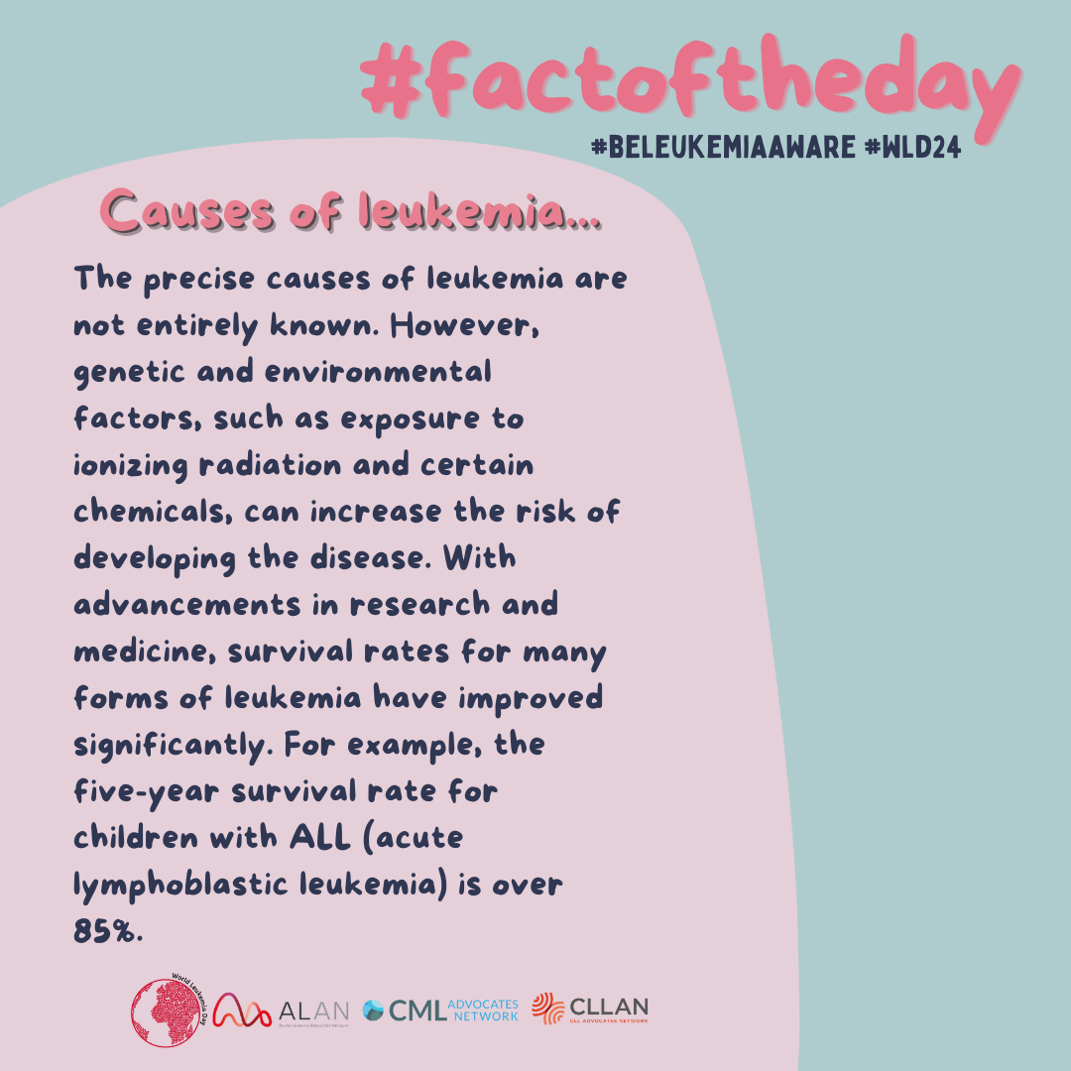

Discover the causes of leukemia and the techniques to cure it in our #factoftheday.
#BeLeukemiaAware#WLD24#WorldLeukemiaDay #patients #yourenotalone#WorldLeukemiaDay #Leukemia #PatientAdvocacy#Alan#BeAware #aboutleukemia #factoftheday #August
Facebook: @ALANacuteleuk @cmladvocates @CLLAdvocates
Instagram: @alan_acuteleuk @clladvocates #cmladvocates

14/08
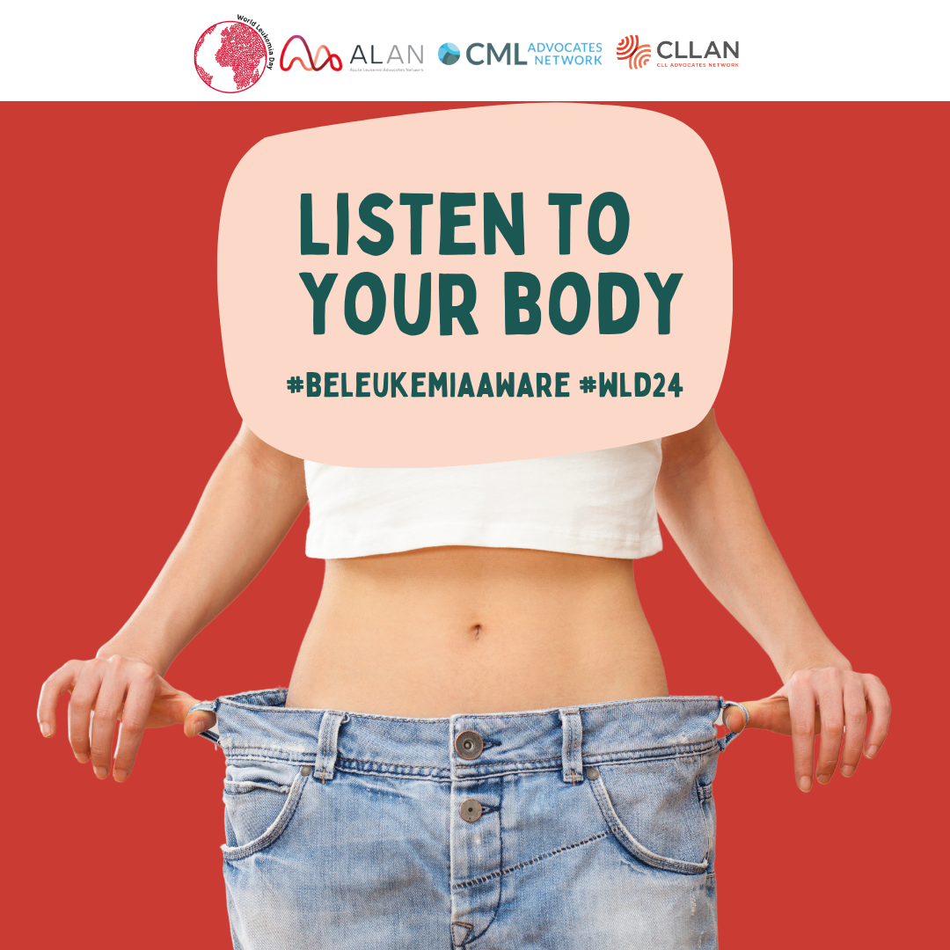

If your weight fluctuates without an apparent reason and in a short period of time, see a doctor... unexplained weight loss can be a symptom of leukemia.
#BeLeukemiaAware#WLD24#WorldLeukemiaDay #support #healthcare #symptoms #leukaemia #yourenotalone#WorldLeukemiaDay #Leukemia #PatientAdvocacy#Alan#BeAware #listentoyourbody #hope #symptoms #August #weightloss
Facebook: @ALANacuteleuk @cmladvocates @CLLAdvocates
Instagram: @alan_acuteleuk @clladvocates #cmladvocates

16/08
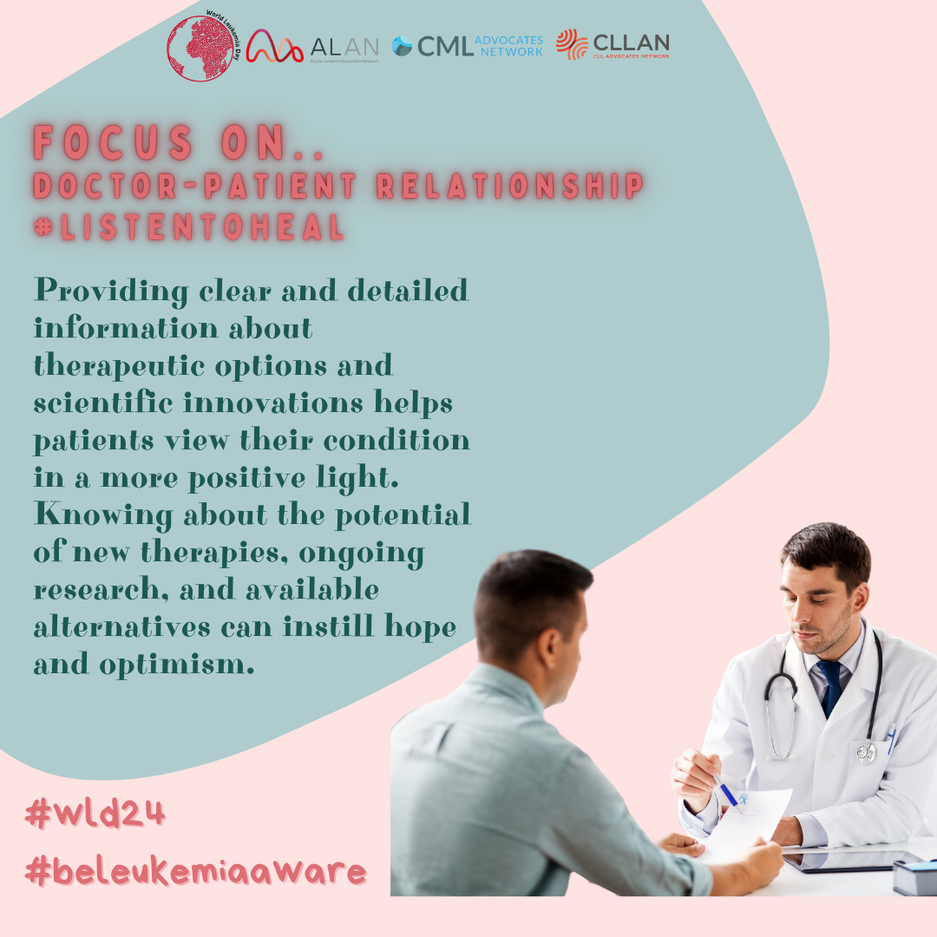

Clear and detailed information allows the patient to have more trust in their doctor and a proactive approach to managing their illness.
#BeLeukemiaAware#WLD24#WorldLeukemiaDay #yourenotalone#WorldLeukemiaDay #Leukemia #PatientAdvocacy#Alan#BeAware #ListenToHeal #FocusOn #Doctor #Patients #August
Facebook: @ALANacuteleuk @cmladvocates @CLLAdvocates
Instagram: @alan_acuteleuk @clladvocates #cmladvocates

19/08
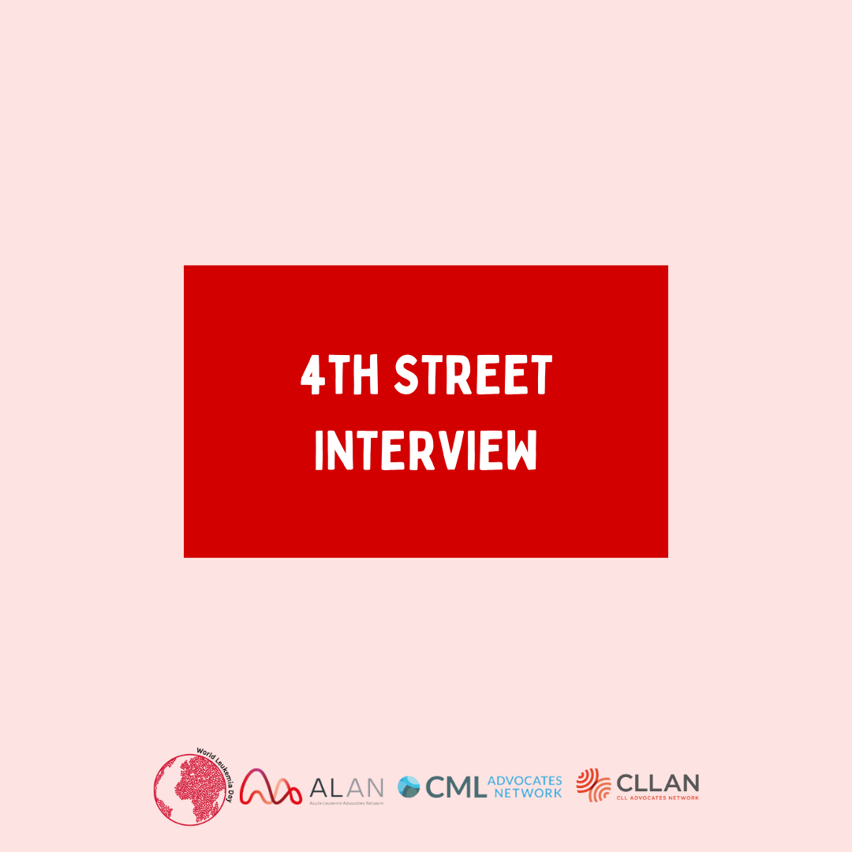
TBD
#BeLeukemiaAware#WLD24#WorldLeukemiaDay#dontignore #loveyourself #yourenotalone#WorldLeukemiaDay #Leukemia #PatientAdvocacy#Alan#BeAware #August #streetinterview
Facebook: @ALANacuteleuk @cmladvocates @CLLAdvocates
Instagram: @alan_acuteleuk @clladvocates #cmladvocates

21/08
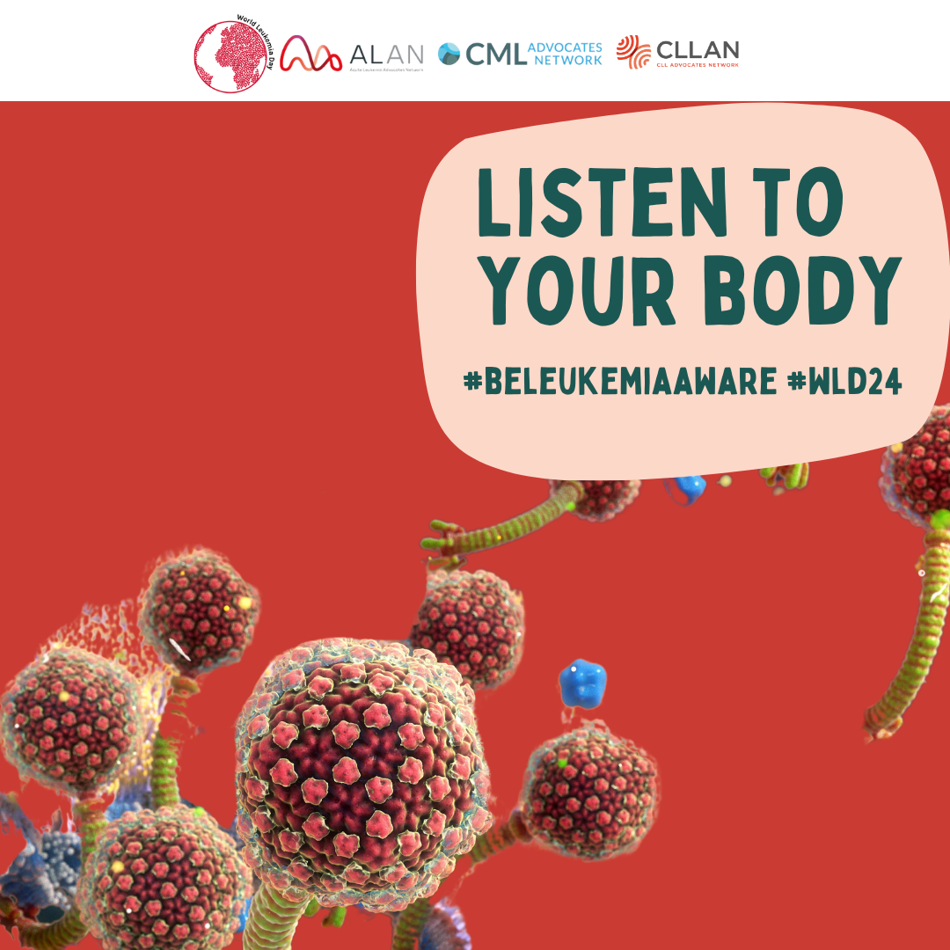

Frequent infections are one of the main symptoms of leukemia; listen to your body because often its signals are a cry for help. Don't waste time and go get a blood test.
#BeLeukemiaAware#WLD24#WorldLeukemiaDay #support #healthcare #symptoms #leukaemia #yourenotalone#WorldLeukemiaDay #Leukemia #PatientAdvocacy#Alan#BeAware #listentoyourbody #hope #symptoms #August #Infections #bloodtest
Facebook: @ALANacuteleuk @cmladvocates @CLLAdvocates
Instagram: @alan_acuteleuk @clladvocates #cmladvocates

22/08
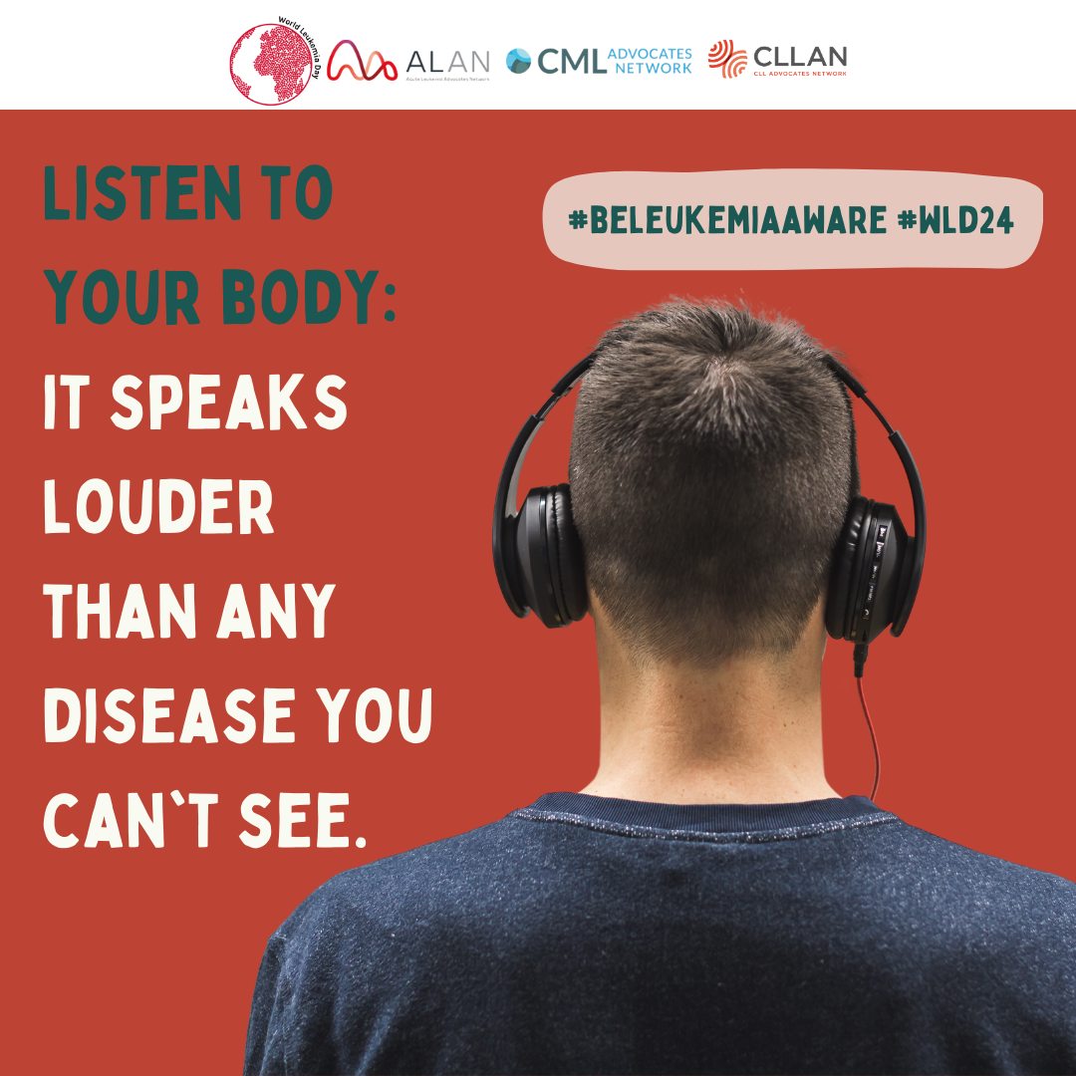

Listen to your body and be aware!
#BeLeukemiaAware#WLD24#WorldLeukemiaDay #support #healthcare #symptoms #leukaemia #yourenotalone#WorldLeukemiaDay #Leukemia #PatientAdvocacy#Alan#BeAware #listentoyourbody #hope #symptoms #August
Facebook: @ALANacuteleuk @cmladvocates @CLLAdvocates
Instagram: @alan_acuteleuk @clladvocates #cmladvocates

23/08
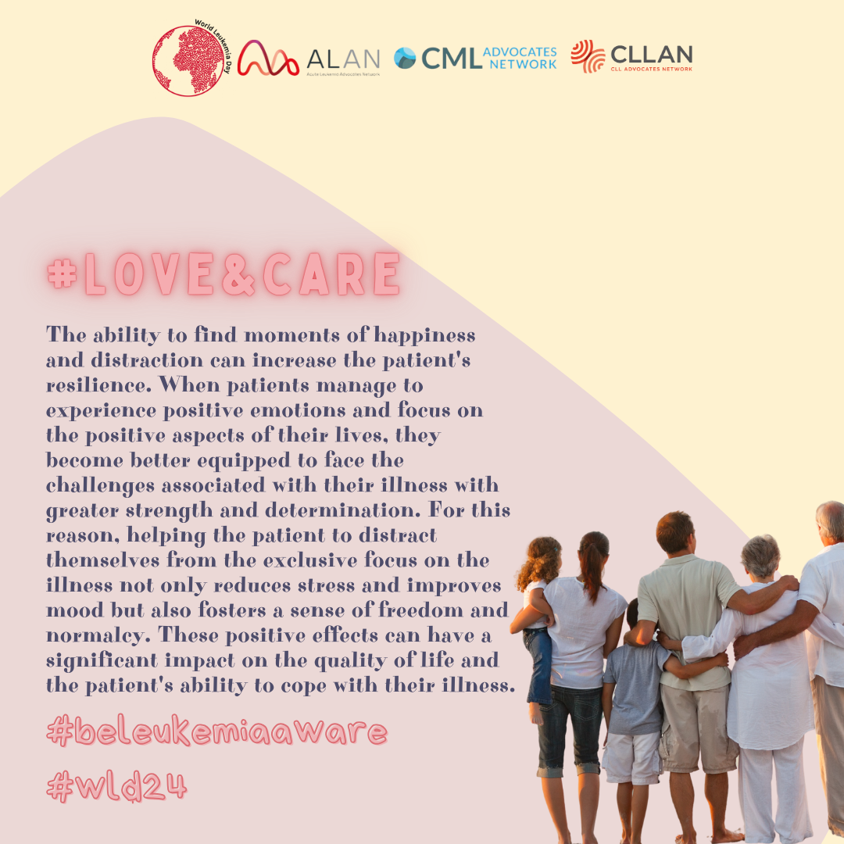

Taking care of others isn't easy, but it can be crucial for a patient who is fighting a battle against illness
#BeLeukemiaAware#WLD24#WorldLeukemiaDay#caregivers #patients #friends #family #yourenotalone#WorldLeukemiaDay #Leukemia #PatientAdvocacy#Alan#BeAware#LoveandCare #August
Facebook: @ALANacuteleuk @cmladvocates @CLLAdvocates
Instagram: @alan_acuteleuk @clladvocates #cmladvocates

26/08
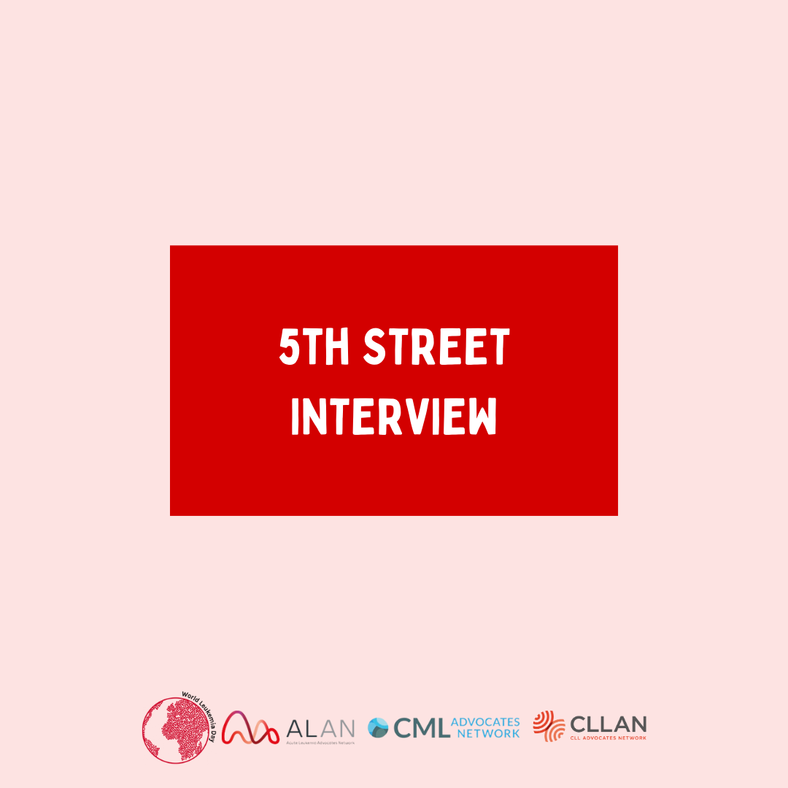
TBD
#BeLeukemiaAware#WLD24#WorldLeukemiaDay#dontignore #loveyourself #yourenotalone#WorldLeukemiaDay #Leukemia #PatientAdvocacy#Alan#BeAware #August #streetinterview
Facebook: @ALANacuteleuk @cmladvocates @CLLAdvocates
Instagram: @alan_acuteleuk @clladvocates #cmladvocates

27/08
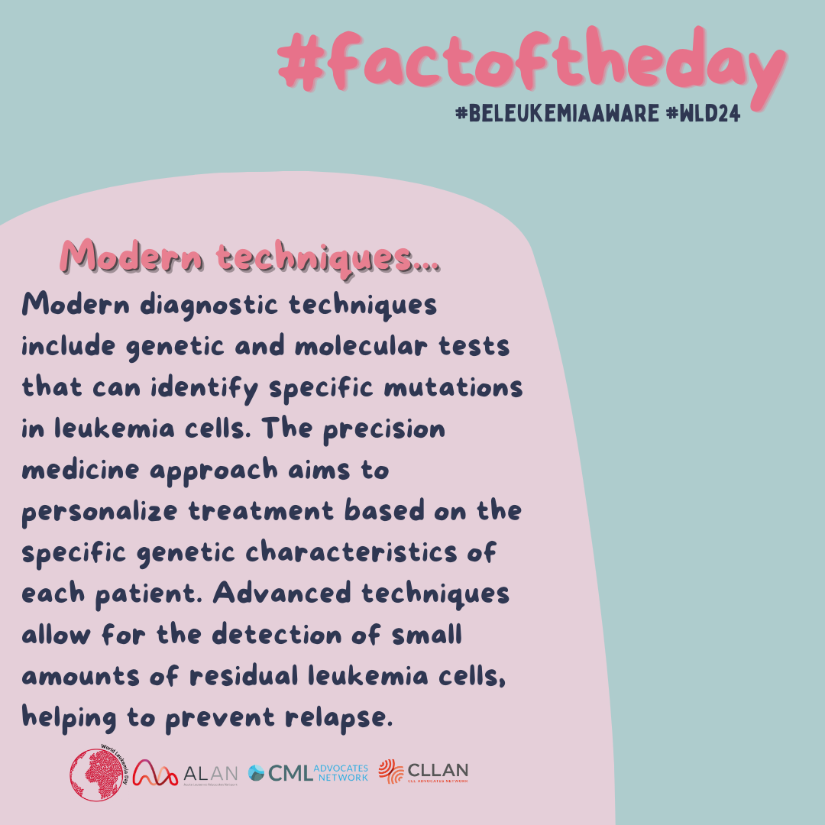
Today, for our #factoftheday series, we discuss the modern techniques used in the treatment of leukemia.
#BeLeukemiaAware#WLD24#WorldLeukemiaDay #patients #yourenotalone#WorldLeukemiaDay #Leukemia #PatientAdvocacy#Alan#BeAware #aboutleukemia #factoftheday #August
Facebook: @ALANacuteleuk @cmladvocates @CLLAdvocates
Instagram: @alan_acuteleuk @clladvocates #cmladvocates

28/08
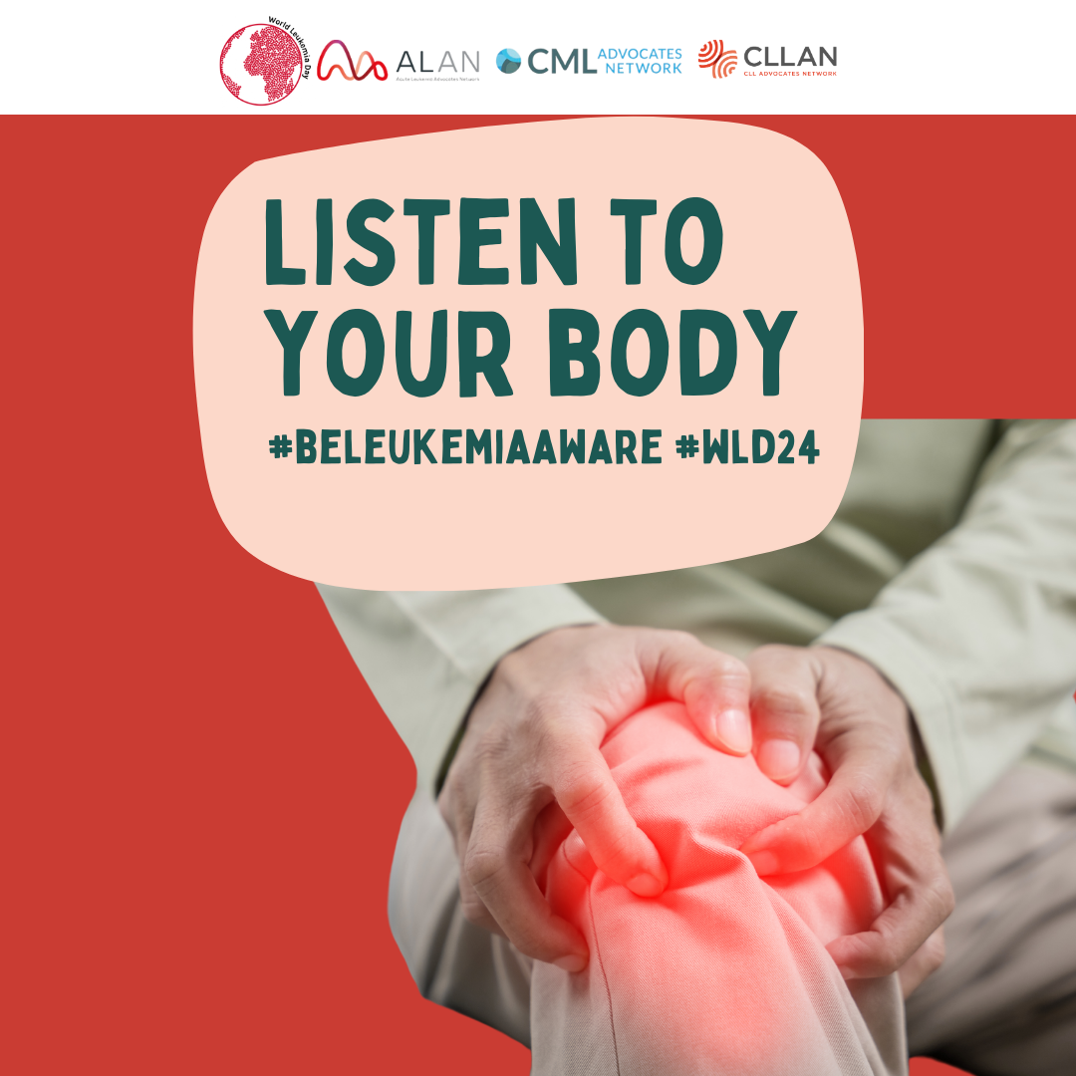

Bone and joint pain, if unexplained, can be a symptom of leukemia. Pay attention to how your body is reacting and don’t ignore anything. If you don’t feel well, see a doctor.
#BeLeukemiaAware#WLD24#WorldLeukemiaDay #support #healthcare #symptoms #leukaemia #yourenotalone#WorldLeukemiaDay #Leukemia #PatientAdvocacy#Alan#BeAware #listentoyourbody #hope #august #bonepain #joinpain
Facebook: @ALANacuteleuk @cmladvocates @CLLAdvocates
Instagram: @alan_acuteleuk @clladvocates #cmladvocates

30/08 9 am
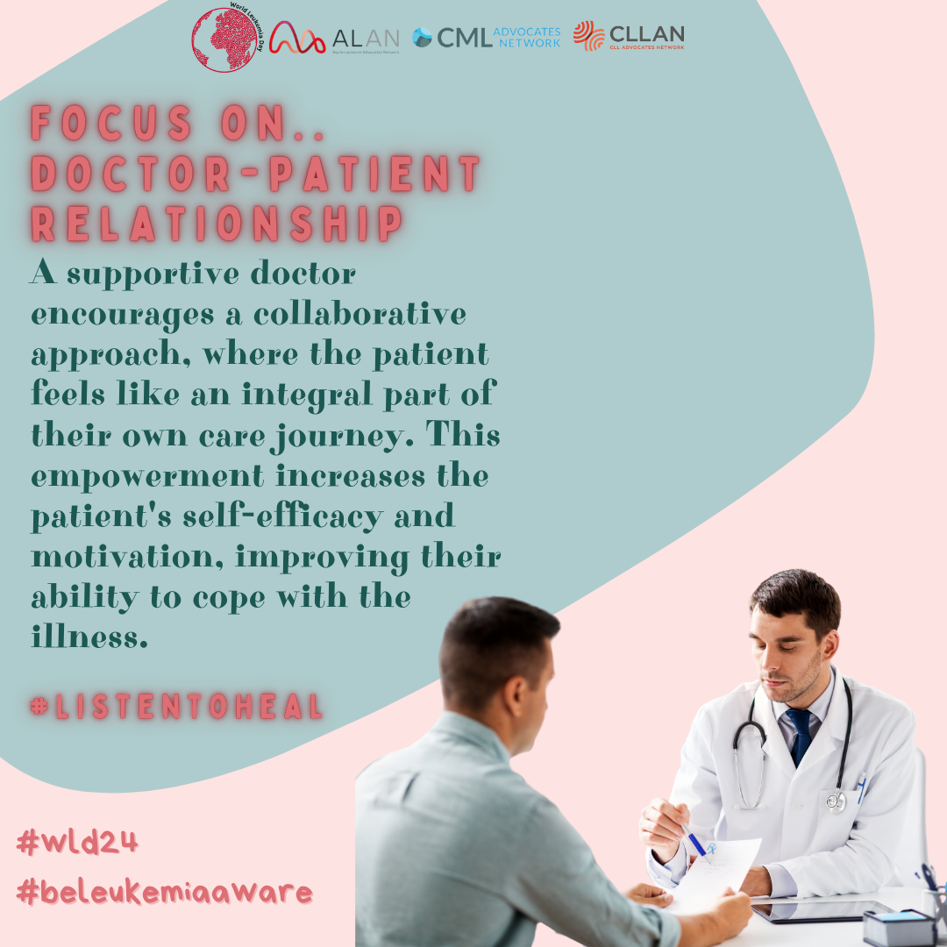
The relationship between doctor and patient should not be overlooked, as it can make therapies more effective.
#BeLeukemiaAware#WLD24#WorldLeukemiaDay #yourenotalone#WorldLeukemiaDay #Leukemia #PatientAdvocacy#Alan#BeAware #ListenToHeal #FocusOn #Doctor #Patients #August
Facebook: @ALANacuteleuk @cmladvocates @CLLAdvocates
Instagram: @alan_acuteleuk @clladvocates #cmladvocates

30/08 3PM
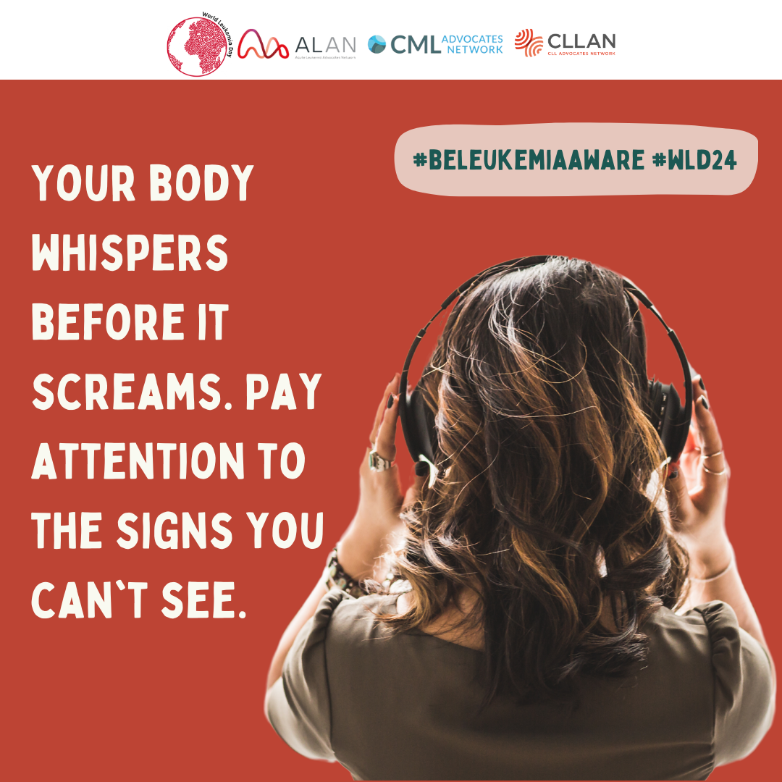
**LISTEN TO YOUR BODY** #BeLeukemiaAware
#BeLeukemiaAware#WLD24#WorldLeukemiaDay #support #healthcare #symptoms #leukaemia #yourenotalone#WorldLeukemiaDay #Leukemia #PatientAdvocacy#Alan#BeAware #listentoyourbody #hope #symptoms #August
Facebook: @ALANacuteleuk @cmladvocates @CLLAdvocates
Instagram: @alan_acuteleuk @clladvocates #cmladvocates

