Post September WLD 2024

02/09: Save the Date #WLD24

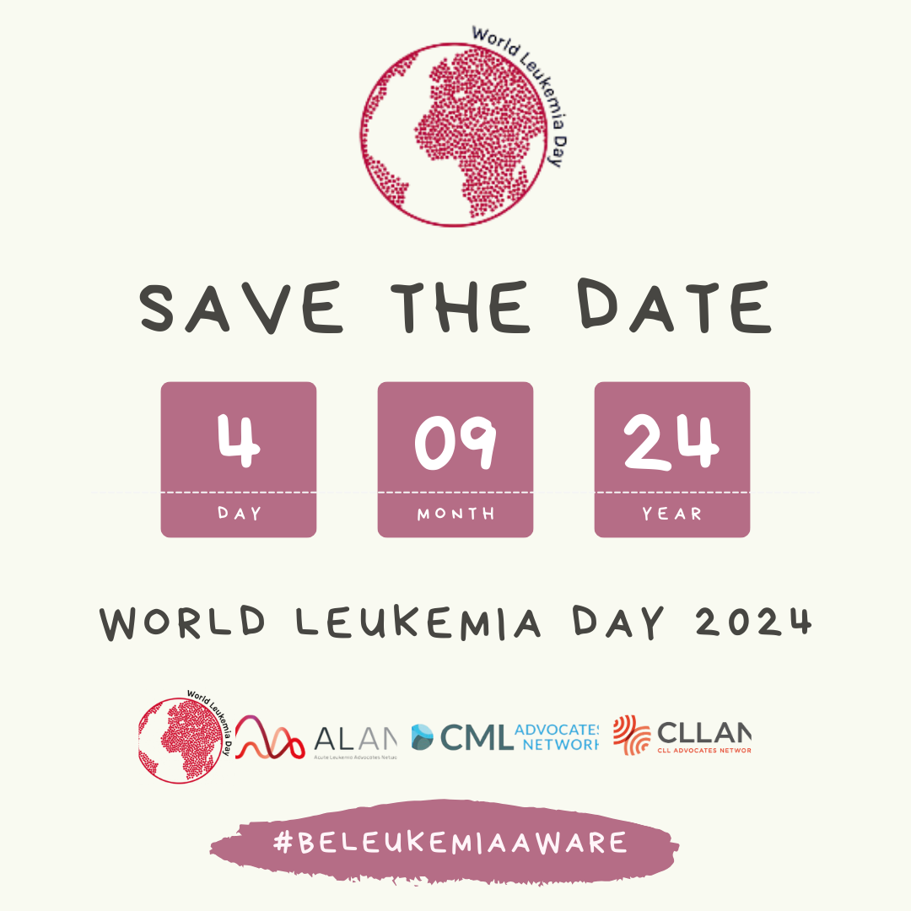

Save the date: only 2 days left until #WLD23.
#BeLeukemiaAware#WLD23#WorldLeukemiaDay#BloodCancerAwarenessMonth #yourenotalone#WorldLeukemiaDay #Leukemia #PatientAdvocacy#Alan#advocacy#SaveTheDate
Facebook: @ALANacuteleuk @cmladvocates @CLLAdvocates
Instagram: @alan_acuteleuk @clladvocates #cmladvocates

02/09: 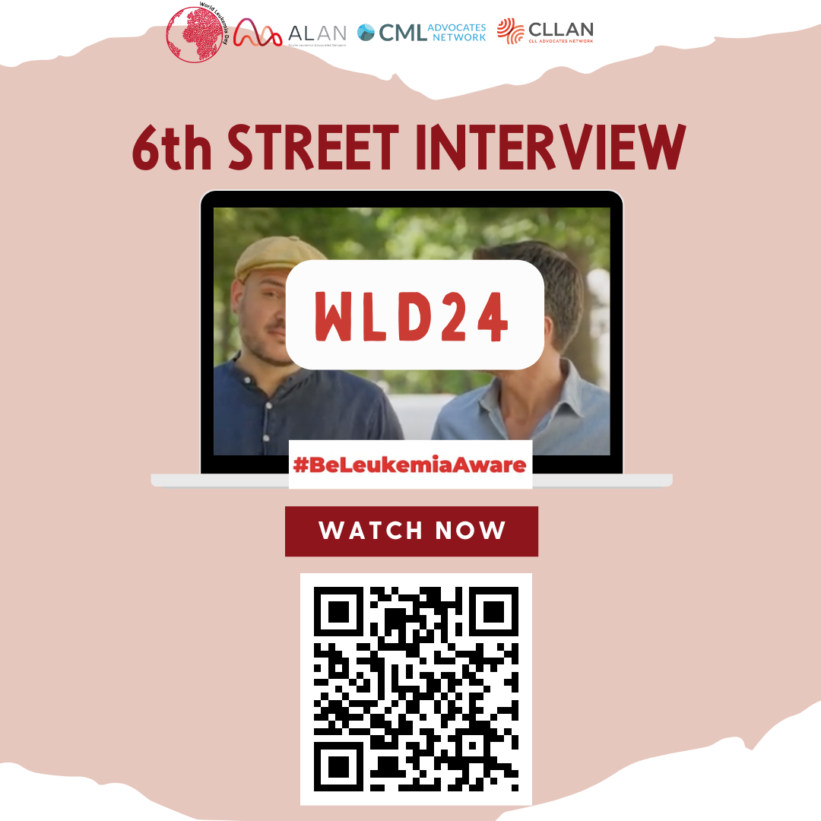

Today, we hit the streets to ask people what they know about leukemia. From misconceptions to personal stories, their answers remind us why raising awareness is so important.
#BeLeukemiaAware#WLD24#WorldLeukemiaDay#BloodCancerAwarenessMonth #yourenotalone#WorldLeukemiaDay #Leukemia #PatientAdvocacy#Alan#StreetInterview #symptoms
Facebook: @ALANacuteleuk @cmladvocates @CLLAdvocates
Instagram: @alan_acuteleuk @clladvocates #cmladvocates
02/09 Blood Cancer Awareness Month

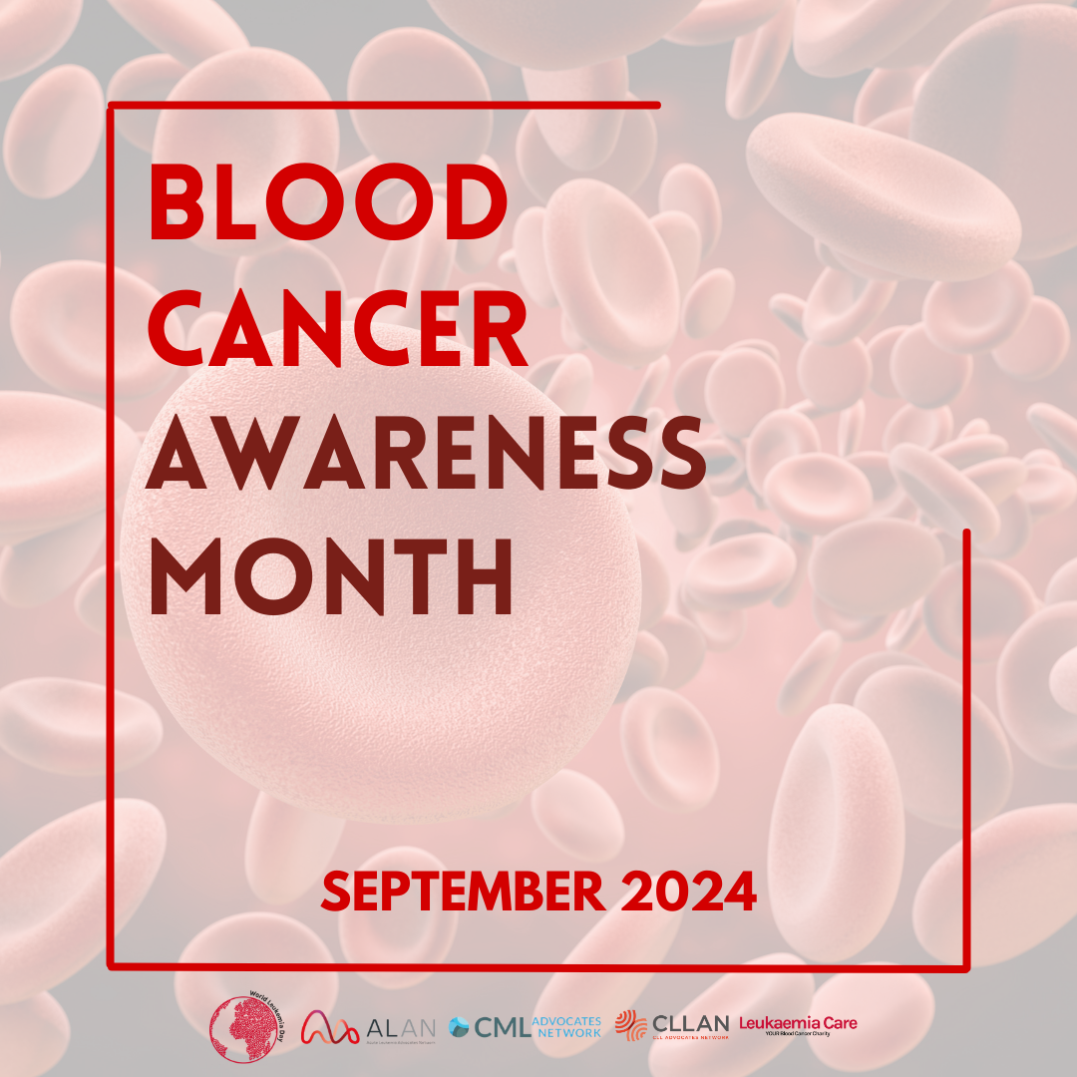
September is a very important month for raising awareness. September is Blood Cancer Awareness Month.
Be Leukemia Aware.
#WLD24
#BeLeukemiaAware#WLD24#WorldLeukemiaDay#BloodCancerAwarenessMonth #yourenotalone#WorldLeukemiaDay #Leukemia #PatientAdvocacy#Alan#advocacy#BloodCancerAwarenessMonth #Awareness
Facebook: @ALANacuteleuk @cmladvocates @CLLAdvocates
Instagram: @alan_acuteleuk @clladvocates #cmladvocates

3/9: Goals #WLD24
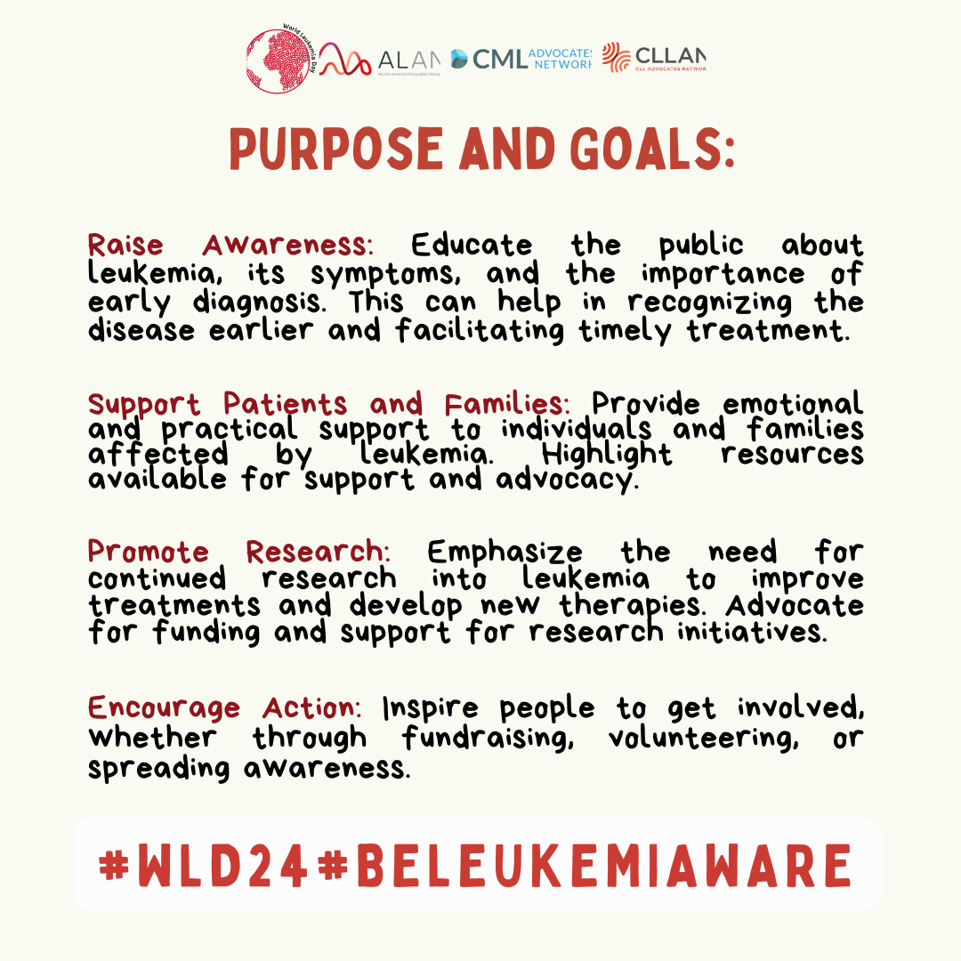
🩸 World Leukemia Day 2024 🩸
"Together, we can fight leukemia and support those who are battling it."
#BeLeukemiaAware#WLD24#WorldLeukemiaDay#BloodCancerAwarenessMonth #yourenotalone#WorldLeukemiaDay #Leukemia #PatientAdvocacy#Alan#Countdown
Facebook: @ALANacuteleuk @cmladvocates @CLLAdvocates
Instagram: @alan_acuteleuk @clladvocates #cmladvocates

3/09: #STREET INTERVIEW #WLD24

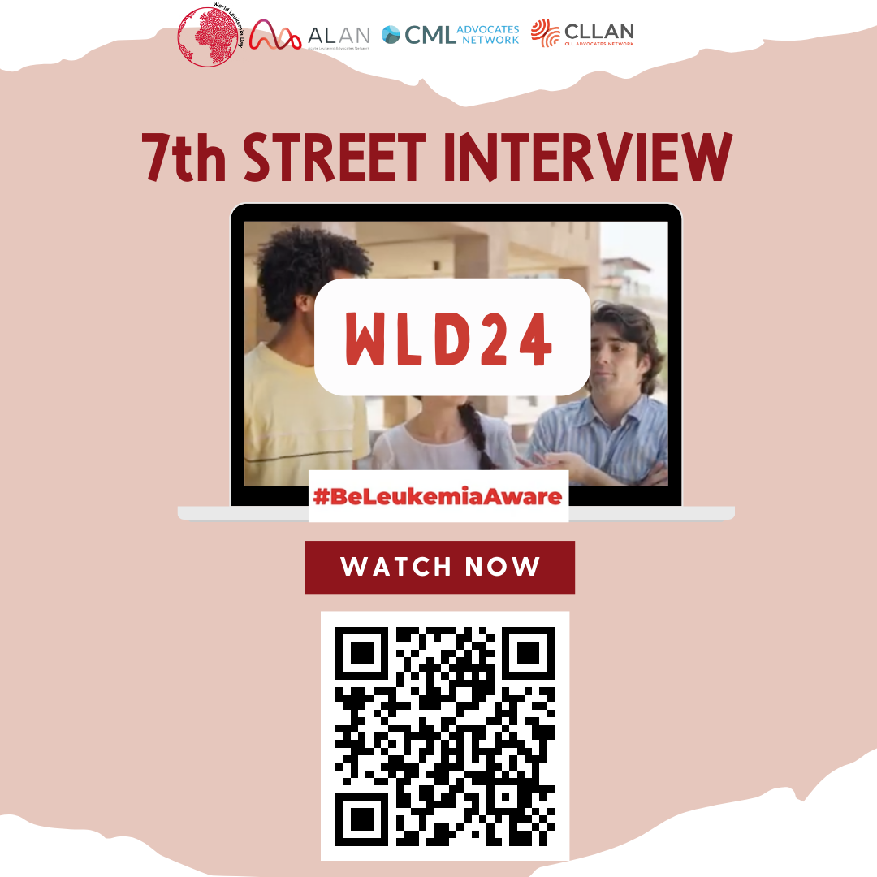

Scan the QR CODE there is last street interview! #WLD24 #WORLDLEUKEMIADAY
#BeLeukemiaAware#WLD24#WorldLeukemiaDay#BloodCancerAwarenessMonth #yourenotalone#WorldLeukemiaDay #Leukemia #PatientAdvocacy#Alan#StreetInterview#Symptoms#Youtube
Facebook: @ALANacuteleuk @cmladvocates @CLLAdvocates @LeukaemiaCare
Instagram: @alan_acuteleuk @clladvocates #cmladvocates @leukaemiacareuk

3/9: What is #WLD24
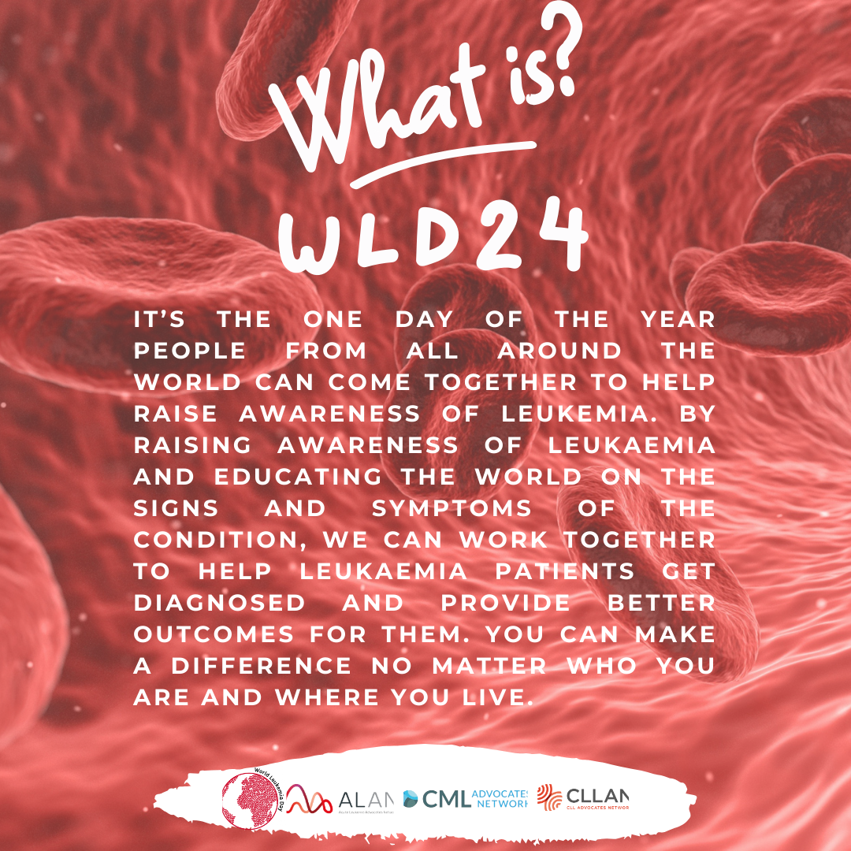

How You Can Make a Difference:
- Spread the Word: Share information about leukemia and its impact on social media and within your community.
- Support Research: Contribute to organizations dedicated to leukemia research or participate in fundraising events.
- Offer Support: Reach out to individuals and families affected by leukemia to offer your encouragement and solidarity.
- Remember: You can make a difference, no matter who you are and where you live!
#BeLeukemiaAware#WLD24#WorldLeukemiaDay#BloodCancerAwarenessMonth #yourenotalone#WorldLeukemiaDay #Leukemia #PatientAdvocacy#Alan#WHATISWLD24
Facebook: @ALANacuteleuk @cmladvocates @CLLAdvocates
Instagram: @alan_acuteleuk @clladvocates #cmladvocates

4/9: Today is #WLD24
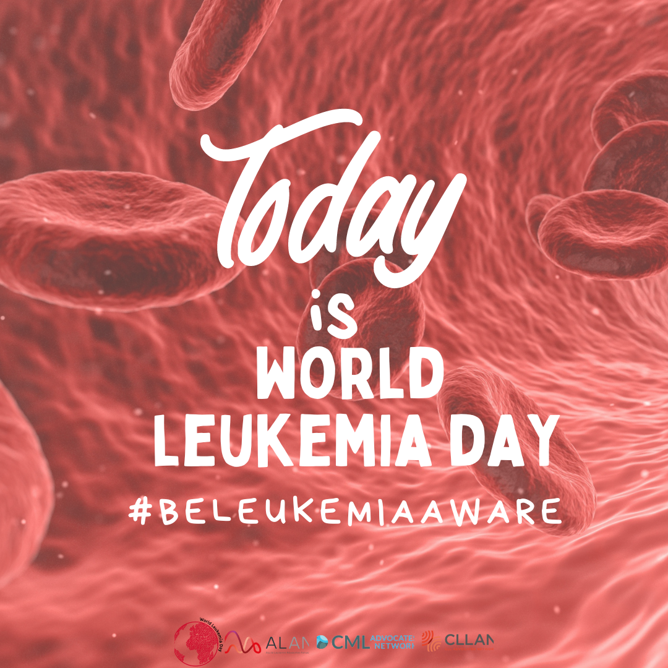

TODAY IS THE DAY! #WLD24 #BELEUKEMIAAWARE

#BeLeukemiaAware#WLD24#WorldLeukemiaDay#BloodCancerAwarenessMonth #yourenotalone#WorldLeukemiaDay #Leukemia #PatientAdvocacy#Alan
Facebook: @ALANacuteleuk @cmladvocates @CLLAdvocates
Instagram: @alan_acuteleuk @clladvocates #cmladvocates

4/9: saves lives #WLD24
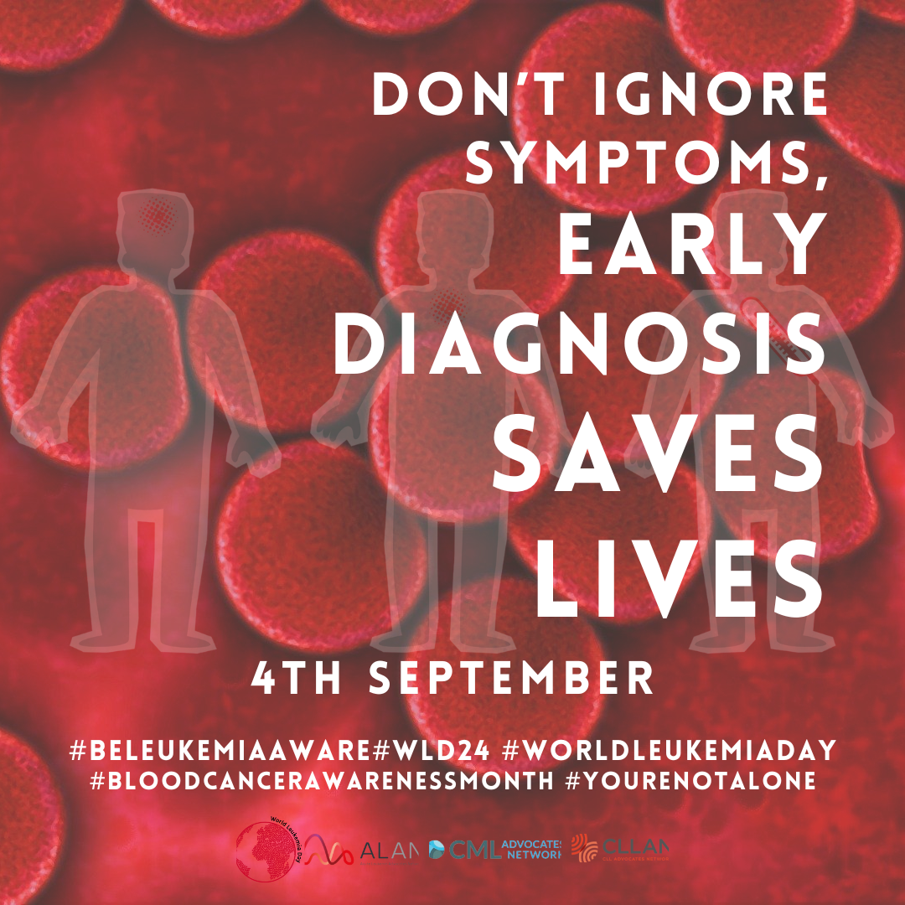

🩸 Together, we are stronger than Leukemia.🩸
#BeLeukemiaAware#WLD24#WorldLeukemiaDay#BloodCancerAwarenessMonth #yourenotalone#WorldLeukemiaDay #Leukemia #PatientAdvocacy#Alan
Facebook: @ALANacuteleuk @cmladvocates @CLLAdvocates @LeukaemiaCare
Instagram: @alan_acuteleuk @clladvocates #cmladvocates @leukaemiacareuk

4/9: #WLD24
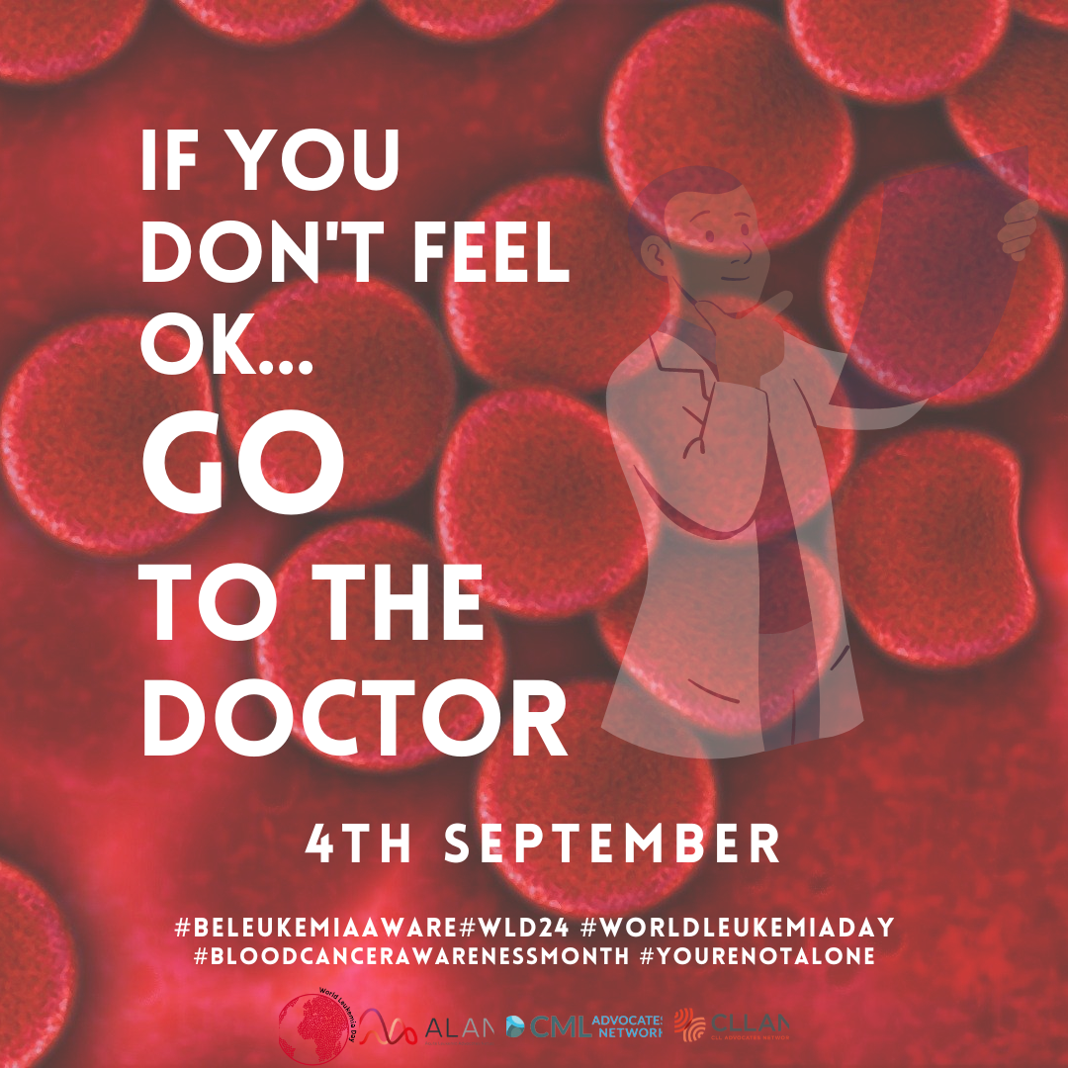

🩺Early detection, awareness, and research are crucial in the fight against leukemia. 🩺
Go to the doctor.
#BeLeukemiaAware#WLD24#WorldLeukemiaDay#BloodCancerAwarenessMonth #yourenotalone#WorldLeukemiaDay #Leukemia #PatientAdvocacy#Alan
Facebook: @ALANacuteleuk @cmladvocates @CLLAdvocates
Instagram: @alan_acuteleuk @clladvocates #cmladvocates

